

**Submitted To**



**Submitted By:**

Cybage Software Pvt. Ltd.

Cybage Towers, Pune - 411014

|  |
| --- |
| Cybage SOLUTION for WPROMOTE INC  ATTRIBUTION AND REPORTING SYSTEM |

# Table of Contents

1 executive summary 3

2 About Cybage 3

3 media and ENTERTAINMENT at cybage 3

4 current scope of work 4

5 proposed Solution 7

6 tools and technologies 13

7 team composition and skill set 13

8 effort Estimates and Pricing structure 13

9 Cost 14

# executive summary

**Cybage Software Pvt. Ltd. (Cybage)** is pleased to submit this proposal to Wpromote Inc. **(Wpromote)**. This proposal has been partitioned to appropriate and essential sections to address the various aspects of the proposal and to satisfy the information needs for the involved stakeholders.

The Cybage team has understood the project requirements based on the visibility so far and is confident that we are equipped with the required technology competency and strong processes and methodologies in place to cater to Wpromote’s requirements.

This proposal document is aimed at providing the following details:

* Proposed business solution for the Attribution and Reporting system
* Proposed cost for the project

***The Proposal shall be valid for 30 (thirty) days after the date of submission to Wpromote*.**

# About Cybage

Founded in 1995, Cybage Software is a leading offshore software services company offering solutions that accelerate, simplify, and enrich business processes to give its clients an edge over competition. We are an SEI CMMI Level 5 version 1.3 and ISO 27001 certified company based in Pune, India. Our success is built on a pool of 4200 software professionals. Based on a remarkable record of quality, consistency, and outstanding technological prowess, we have partnered with over 170 global software houses of fine repute. Our array of services includes Product Engineering (OPD), Enterprise Business Solutions, and Value Added Services. Cybage specializes in the implementation of the Offshore Development model.

Headquartered in Pune, we also have offices in Hyderabad and Gandhinagar in India and a development center in Redmond, Washington and marketing and business development offices in New Jersey, Georgia, California, and Texas in the USA and London, UK. Cybage’s domain expertise spans across several business verticals such as Media and Entertainment, Travel and Hospitality, Healthcare and Life Sciences, Retail and Distribution and Hi-Tech. Cybage has seven defined technology focused CoEs - eCommerce, Enterprise Mobility, Customer Relationship Management, Business Intelligence, Enterprise Content Management, Cloud Computing and Supply Chain Management. Our unique model of operational efficiency, **ExcelShore®,** helps ensure de-risk our approach and provide the best value per unit cost.

# media and ENTERTAINMENT at cybage

With a presence spanning more than 14 years, the Media and Entertainment practice at Cybage now engages with more than 35 customers across North America, Europe, and Asia Pacific. A team of more than 700 software professionals serve domains that include the following:

* Media
* Advertising
* Publishing
* Mobile and Emerging Media
* Gaming
* Entertainment

Cybage has two distinct offerings for its customers in the **Advertising and Social media space**—technology services and managed services. On the technology implementations, Cybage has been working with industry majors in Interactive Advertising for the past several years and has attained expertise in this niche area. We work with all sections of businesses in the Interactive Advertising space, and our teams are knowledgeable with the workflow and integration points within the Interactive Advertising framework. Our customers include worldwide leading names, which are among the following domains:

* Ad Exchanges, Networks, and Ad Serving Platforms
* Media Houses and Ad Agencies
* Online Publishers

Our expertise in the Interactive Advertising space includes building technology solutions and offering managed services related to the following:

* Search marketing
* Social media integration
* Social Media Marketing (SMM) and Reputation management
* Display advertising
* Real-time bidding, Digital Signal Processing (DSP), and SSP
* Video advertising
* Mobile advertising
* Affiliate marketing
* Email marketing
* Analytics and ROI measurement

# current scope of work

The scope of this project focuses on the development and implementation of an Attribution and Reporting system that would help Wpromote and its customers derive insights into how their marketing and advertising campaigns are performing across multiple channels. Thus, the scope of this project focuses on three broad aspects:

* Aggregating, analyzing, and processing advertising data from various sources
* Implementing attribution and data logics
* Implementing a front-end dashboard to access attribution reports and analytics

***Please note:*** The following requirements have been included on the basis of our understanding of Wpromote’s requirements and may change based on priorities and information as and when provided by the latter. Wpromote can choose to prioritize or rearrange features as per their business needs.

## **REQUIREMENTS**

The first milestone of the project would primarily focus on developing the required back-end infrastructure for data aggregation and processing and the associated reporting framework for the dashboard. As part of the data processing, we would develop and implement attribution logics to derive comprehensive insights for Wpromote and its customers.

The following table details the requirements or the features we have considered as part of phase 1 of this project.

|  |  |
| --- | --- |
| Requirements | Details |
| Integration of data sources | * Data sources considered for phase 1 are the following:   + Google search: Paid and Natural Search   + Google adwords   + Google Multi-Channel Funnel (MCF) reporting   + Bing search: Paid and Natural Search   + Bing ads   + Facebook   + Google DoubleClick   + Email (efforts and costs for any one provider included) |
| Development of Extract Transform Load (ETL) and data processing systems | * Integration of data source services or APIs with back-end ETL system * Implementation of databases to store transactional and raw data * Data and attribution modeling * Attribution and associated business logics |
| Reporting and Analytics dashboard | * Multitenancy and customer management * Admin interface and application management * Customizable parameters (for example, weighted attribution and decay, among others) * Reports:   + Wpromote: High-level report:     - Customer-level report:     - Network-level report:       * Campaign-level report:         + By location         + By time         + By conversion lifecycle         + By conversion lead time         + Average position         + Clicks         + Impressions         + Click Through Rate (CTR)         + Cost per Click (CPC)         + Cost         + Conversions         + Conversion rate         + Cost per conversion         + Revenue         + Return on Advertising Spend (ROAS) |

***Current scope of work***: The following would be the extent of tasks undertaken as part of this development project. These tasks have been identified after analyzing the requirements.

|  |  |
| --- | --- |
| Sr. No. | Task or feature description |
|
|  | **Generic implementation phase** |
| 1 | **Requirements** |
|  | Requirement gathering and analysis |
|  | Documenting requirement understanding |
|  | Development and test environment setup |
| 2 | **Design** |
|  | Detailed architecture design, data warehouse design, and document |
| 3 | **Construction - Administration Module** |
|  | Admin application management or settings (includes user login, user management, and customer management) |
|  | Customizable parameters (for example, weighted attribution and decay, among others): customer-level, user-level parameter setting interface |
|  | Admin DB design and implementation |
| 4 | **Construction - Reporting module** |
|  | Basic reporting framework |
|  | Attribution reports (approx. 10 reports) |
|  | Ad reports (approx. 10 reports) |
| 5 | **Integration with external data sources** |
|  | Google search: Paid and NATURAL SEARCH |
|  | Google adwords |
|  | Google Multi-Channel Funnel (MCF) reporting |
|  | Bing search: Paid and NATURAL SEARCH |
|  | Bing ads |
|  | Facebook |
|  | Google DoubleClick |
|  | Email marketing service provider |
| 6 | **ETL** |
|  | Integrating data source services or APIs with back-end ETL system |
|  | Implementation of databases to store transactional and raw data |
|  | Data and attribution modeling |
|  | Attribution and associated business logics |
| 7 | **Construction - User action tracking and attribution module** |
|  | Cookie creation using pixel/script, logging the user request |
|  | Cookie based unique user identification module |
|  | Click, conversion data gathering and cleansing |
|  | Conversion attribution logic to create data ready for reporting |
| 8 | **Build, release, and deployment** |

*This list represents high-level features, and tasks. Detailed tasks or activities would be identified and elaborated during the Requirement and the Design phases and would be included in the project plan.

# proposed Solution

To create an Attribution and Reporting system, Cybage proposes a solution that would primarily consist of the following components:

* Data aggregation and sources
* Wpromote HTTP handler and cookie-based tracker
* ETL and database layer
* Dashboard and Reporting layer

The following diagram represents the earlier mentioned components and how they would interact with one another.

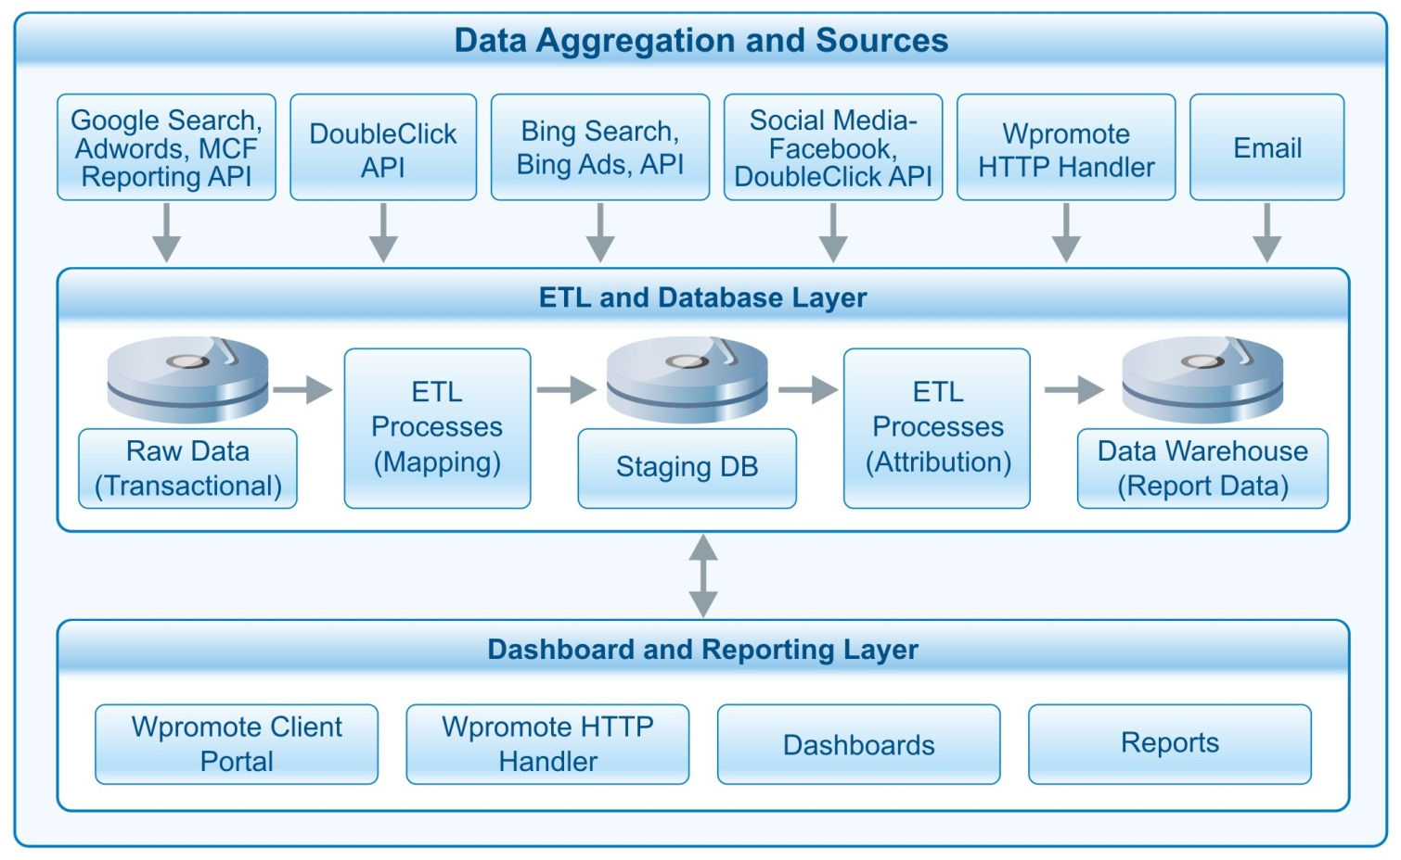

The following sections detail each of these components.

## **Data Aggregation and Sources**

Specified that Wpromote and its customers run multiple campaigns across various channels capitalizing on third-party networks and exchanges, a critical aspect of this application would be aggregating data from the latter. To aggregate such data, Cybage would capitalize on the third parties’ web services and APIs to pull data. The raw data so aggregated would be stored in a transactional database for further processing. The following table illustrates the type of data and the source from where it would be aggregated.

|  |  |  |
| --- | --- | --- |
| Data | Source | Data |
| Unique identifier | Cookie data | * Unique user ID * User information on subsequent logons * IP address and time stamp |
| Transactional data | Google Analytics and  Cookie data | * IP address * Time stamp * Geo-location |
| Ad data | Third parties | * Campaign data * Average position * Clicks * Impressions * CTR * CPC * Cost * Conversions * Conversion rate * Cost per conversion * Revenue * ROAS |
| Conversion path data | Google MCF reporting API | * Average number of clicks to conversion * Average lead time per click * Average time spent on page * Break down by geo-location |
| Conversion tracker | Pixel and Cookie data | * User unique identifier * Pixel data |
| Email data | Email service provider (only 1 source, costing details included for each additional data source) | * Clicks * Impressions (open rate) * Conversions * Associated email data as required |

## **Wpromote HTTP Handler and Cookie-Based Tracker**

While third parties provide comprehensive data, Cybage proposes the use of cookie-based tracking to attribute clicks. These cookies can be downloaded onto the user’s browsers by creating an interim URL between the ad and the ad’s landing page. Further, Wpromote can validate conversions by including tracking pixels within the ad’s landing page. This would further validate the attribution model and provide an alternative to third parties’ conversion tracking reports. The following flowchart details the use of a cookie-based tracker in conjunction with third parties.

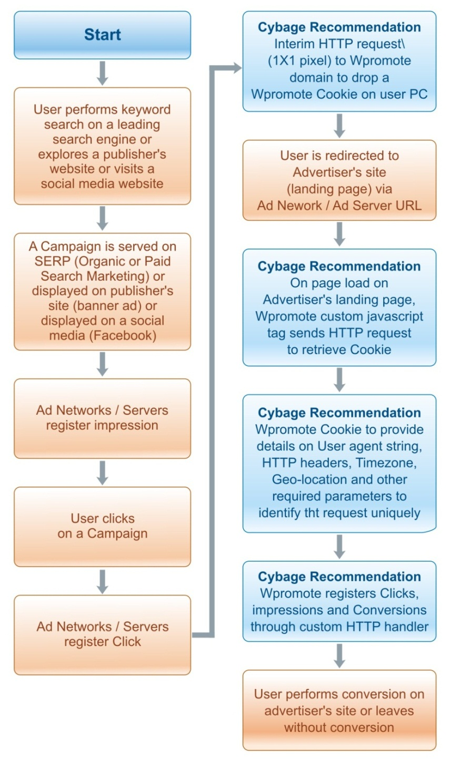

The system to be developed would allow the Wpromote admin users to manage and implement this cookie-based tracker across ad campaigns and advertiser sites.

## **ETL and database Layer**

After the data has been aggregated, an ETL process would map the data based on the logics defined. The following table illustrates how various data sources would be mapped using common parameters or fields available. Establishing this mapping would enable us to further process data and provide comprehensive insights using drill-downs and cross-tabs, among others.

## Database Mapping

|  |  |  |
| --- | --- | --- |
| Google AdWords | Google  DoubleClick (DFA) | Bing search or ATLAS |
| Fields | **Fields** | **Fields** |
| Campaign ID | Campaign ID | Campaign ID |
| Campaign Name | Campaign Name | Campaign Name |
| Site Name | Site Name | Site Name |
| Date | Date | Conversion Action Time |
| Placement URL | Placement | Placement ID |
|  | *Ad Name\** | *Ad Group Name* |
| Creative Type | Creative Type | Creative GUID |
|  | *Ad Type* | *Creative Description* |
| *Creative Name* | *Creative Name* |  |
| *Creative Size* | *Creative Size* |  |
|  |  |  |
| Metrics | **Metrics** | **Metrics** |
| Impressions | Impressions delivered | Impressions |
| Clicks | Clicks delivered | Clicks |
| Cost | Media cost | Cost method |
| Click rate | Click rate | CTR |
| *Average CPM* | *Effective CPM* |  |

*The data fields in italics represent fields that are not available in some data sources and may not be mapped.

In addition to the mapping process, there would be another ETL process that would process the data as per the attribution data that has been defined. The data derived as the outcome of this process would be reporting ready and stored in a data warehouse for consumption by the dashboard and the reporting layer.

## Attribution Model

Developing the attribution models would be a critical step in determining how credit for sales and conversions would be assigned to interactions within the conversion path. Specified that the business contexts are varied for campaigns run, we propose the use of context-based attribution models. These models could be applied to campaigns based on what Wpromote or its customers deem as appropriate for the context.

**Attribution models**

|  |  |
| --- | --- |
| Model | Descriptions |
| Last click or interaction | This attribution model would allot 100 percent of the credit of the conversion to the last click or interaction made by the user. |
| First click or interaction | This attribution model would allot 100 percent of the credit of the conversion to the first click or interaction made by the user. |
| Linear attribution | All clicks and interactions in the conversion path would be provided equal credit for the conversion. |
| Time decay | In this model, the click or the interaction closest to the conversion time would be given higher credit. |
| Reverse time decay | This model, similar as the earlier one, would give clicks or interactions at the start of the conversion path higher credit for the conversion. |
| Position based | This model would attribute credit based on the position of the click or the interaction. |
| Custom attribution | This would be a configurable model that could be used in conjunction with linear, time, or position-based attribution. |

We would create these attribution models as highly flexible and easy-to-apply options within the reporting interface. This would allow users to choose and define the attribution models to be used for various campaigns.

## Dashboard and Reporting layer

This layer represents the front-end client that would allow Wpromote and its customers to access reports, analytics, and options for the system. The dashboard would support multitenancy and integrate heavily with the data warehouse.

Following is the illustrative report structure. Based on Wpromote and its customers’ requirements, additional reports could be added and enhanced.

***Overview Report*** *(A snapshot of total clicks, impressions and conversions):*

Reports:

* clicks
* impressions
* conversions

Report columns (data sources):

* Google Analytics (Search - Paid and Organic)
* AdWords
* DoubleClick
* Bing (Search, Display)
* Wpromote Custom (Cookie based tracking)
* Email
* Facebook (data through DoubleClick)
* Google MCF

***Interaction Report*** *(A snapshot of No. of Interactions by users resulting in conversion):*

Reports:

* interaction path length

Report columns:

* conversions
* conversion values
* for data sources:
  + Google Analytics (Search - Paid and Organic)
  + AdWords
  + DoubleClick
  + Bing (Search, Display)
  + Wpromote Custom (Cookie based tracking)
  + Email
  + Facebook (data through DoubleClick)
  + Google MCF

***Time Lag Report*** *(A snapshot of No. of days taken for conversion):*

Reports:

* Time lag in days

Report columns:

* conversions
* conversion values
* for data sources:
  + Google Analytics (Search - Paid and Organic)
  + AdWords
  + DoubleClick
  + Bing (Search, Display)
  + Wpromote Custom (Cookie based tracking)
  + Email
  + Facebook (data through DoubleClick)
  + Google MCF

***Conversion Path Report*** *(A snapshot of No. of Top Conversion Paths - includes group by conversion medium, keyword, Campaign):*

Reports:

* Conversion path for source/medium

Report Columns:

* conversions
* conversion values

***Attribution Report*** *(User could give weights to each channel and re-generate report. First Interaction, Last Interaction, Linear, Time Decay, Position Based)*

User could select attribution type (First interaction, linear, last interaction, time decay, custom)

Reports:

* Source/Medium

Report columns:

* First interaction conversions
* First interaction conversion value
* Last interaction conversions
* Last interaction conversion value
* For data sources:
  + Google MCF
  + Wpromote Custom

## **assumptions**

* Wpromote would provide user credentials for external data sources and APIs where applicable.
* Wpromote would push the deployed application on the production environment after user acceptance testing (UAT) on the staging server. The Cybage team would assist in the deployment process.
* Cybage has considered efforts for developing approx. 10 reports. Any additional reports would be implemented at additional efforts and cost.
* Cybage’s recommended approach on custom cookie based tracking along with pixel tracking would require Wpromote to integrate a script on its advertisers websites / landing pages.

# tools and technologies

* Java and J2EE
* Pentaho Kettle
* Apache Tomcat

# team composition and skill set

* One UI Designer
* Two BI Developers
* Three Java Developers
* One QA Engineer
* One Project Manager

# effort Estimates and Pricing structure

## **EFFORT ESTIMATES**

|  |  |
| --- | --- |
| SDLC Phase / Milestone | Total  Effort  (Person days) |
| Requirement gathering and Development Environment Setup & System Design | 60 |
| UI Design, Coding & Unit Testing | 300 |
| System Testing / QA | 80 |
| Total Effort | **440** |

**Please note:**

The estimated efforts represent ballpark estimates and actual efforts may vary depending on the requirement phase and architecture and DW design for the proposed system.

Total effort in person days**: 440**

Total Dev and QA effort in person months**: 22**

Project Management Effort**: 2.25 person months**

## resource loading

|  |  |  |  |  |  |
| --- | --- | --- | --- | --- | --- |
| Resource Type | Month 1 | Month 2 | Month 3 | Month 4 | Month 5 |
| UI Designer | 1 | 1 |  | - | - |
| Developers | 2 | 2 | 4 | 4 | 4 |
| QA |  | 1 | 1 | 1 | 1 |
| Project Manager | 0.25 | 0.50 | 0.50 | 0.50 | 0.50 |

*The resource loading is tentative. Actual project duration may vary depending on the resource loading and scheduling on project plan.

Total duration in calendar months**: 5**

# Cost

## **additional cost for data sources and APi**

As proposed in Requirements above, the below input data sources will be required for developing the Attribution and Reporting system.

WPromote will need to subscribe to these APIs/ data feeds and provide access to Cybage development team, for WPromote accounts setup in these systems.

* Google search: Paid and NATURAL SEARCH:
  + Data source: Google Analytics Core Reporting API (v3)
  + Overview: <https://developers.google.com/analytics/devguides/reporting/core/v3/>
  + Data points (Dimensions and Metrics):

<https://developers.google.com/analytics/devguides/reporting/core/dimsmets#cats=visitor,session,trafficsources,adwords>

* + Quota policy: <https://developers.google.com/analytics/devguides/reporting/core/v3/#quota_policy>
* Google AdWords:
  + Data points: <https://developers.google.com/adwords/api/docs/appendix/reports>
  + API pricing details: <https://developers.google.com/adwords/api/docs/ratesheet>
* Google Multi-Channel Funnel (MCF) reporting for Attribution reporting:
  + Overview: <https://developers.google.com/analytics/devguides/reporting/mcf/v3/>
  + Data points (Dimensions and Metrics):

<https://developers.google.com/analytics/devguides/reporting/mcf/dimsmets/>

* + Quota policy: <https://developers.google.com/analytics/devguides/reporting/mcf/v3/#quota_policy>
* Google DoubleClick:
  + Attribution modeling in DFA
  + DFA Reporting API v1.1: <https://developers.google.com/doubleclick-advertisers/reporting/v1.1/>
  + Data points (Dimensions and Metrics):

<https://developers.google.com/doubleclick-advertisers/reporting/v1.1/dimensions>

* + Wpromote would need to subscribe to DoubleClick at an additional cost to buy required Cookie data.
* Bing search: Paid and NATURAL SEARCH and Bing ads:
  + Bing search and ads tracking could be configured with Google Analytics.
  + Also, Bing provides APIs to query raw data with dimensions and metrics required for reporting.
* Facebook:
  + Facebook allows DoubleClick ads, and ad analytics for Facebook ads could be derived from DoubleClick APIs.
* Email:
  + Wpromote would need to get raw data on email campaign impressions (open rate) and other required parameters from Email marketing service provider.
  + Cybage could help build HTML email marketing campaign mailers, which could be configured and tracked using Google MCF reporting APIs.
  + Cybage has considered one email marketing service provider as Email data source when estimating efforts in getting raw data and performing ETL. Additional sources for Email data will be accommodated at an approximate additional effort of **one person week** and associated cost as per our rate card.

The proposed system would query the earlier data sources to get the raw data through the API call. Out of the earlier mentioned sources, querying some data sources such as Google AdWords and DoubleClick would involve additional cost for pulling specific raw data around attribution metrics. For example, the proposed Attribution and Reporting system would require buying DoubleClick cookie data to derive metrics and reporting.

Wpromote would need to subscribe to such paid APIs (where applicable) and work out deal with DoubleClick to buy cookie data.

# post-deployment support and Cybage value added services

***Post-deployment support***:

Cybage also offers post-deployment sustained engineering and maintenance services for newly released applications. Our service offerings in this space help address ongoing maintenance of applications while providing optimal resources to accomplish any feature enhancements or upgrades. Typically, sustained engineering and maintenance services are ongoing engagement between Cybage and its client(s). Such an engagement includes a team that undertakes:

* Off and on-site maintenance
* Bug fixing and trouble shooting
* Bug tracking and reporting
* Fine-tuning and improvement to product functionality
* Research, design and implementation of new features

Post-deployment of the proposed system, Cybage proposes to retain a smaller core team to help with future enhancements and other initiatives. The same team can also work on bug fixes and change requests. Wpromote will have the liberty to prioritize and assign tasks for them.

***Value added services***:

Cybage also offers following value added services:

* **Technical Support**: Some of the most significant service offerings that are included in our vast array of support services are application and product support, technical and customer helpdesk, remote infrastructure management, data management and transaction processing. For more details, please visit: <http://www.cybage.com/pages/value-added-services/technical-support.aspx>
* **User interface Design**: The Cybage UI Team has a spectrum of services for our customers, ranging from Usability Practices to Web Development. These services include - usability, corporate communication, visual design, RIA and web development. For more details, please visit: <http://www.cybage.com/pages/value-added-services/user-interface-design.aspx>
* **Documentation**: The Documentation Services at Cybage are broadly classified into technical documentation (installation/config. Guides, online help, user admin guides, product manuals, API/SDK manuals, release notes), multimedia tutorials and content writing. For more details, please visit: <http://www.cybage.com/pages/value-added-services/documentation.aspx>